**For Assignment 1, solve and submit any 1 question from each section.**

**Section 1**

1. Mention a problem of Structured Programming.
2. What are the different members in a class?
3. What are the special features of a Constructor function?
4. What is function overloading? How are different overloaded functions identified? Explain with examples and mention any advantages.

**Section 2**

1. Which of the below code contains correct overloading code? Why would the other won’t work?

|  |  |
| --- | --- |
| **Code 1**  double myMultiply (int x){             return 10 * x;  }  double myMutiply (double x){             return 20 * x;  } | **Code 2**  int myMultiply (int x){             return 10 * x;  }  double myMutiply (int x){             return 20 * x;  } |

1. What is the output of the following code:

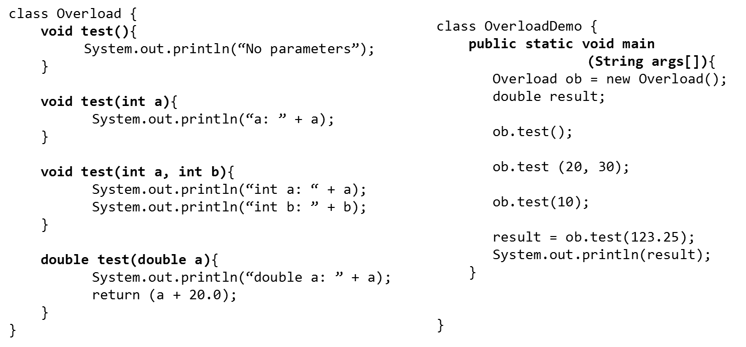

**Section - 3**

1. Write a class for ‘LabRoom’; it will have member fields for no of chairs, no of tables, no of computers. The class should also contain methods to add or remove these elements: the amount to be added or removed should be given as parameter. Now, Create 2 LabRoom objects- one object with 20 chairs, tables and computers; the other with 20 tables, 18 chairs and 15 computers. Then add necessary tables, chairs or computers to make the second object as same as the first object.
2. Write a class ‘Box’ which has three members height, width and depth; To set values and use these members, write mutator and accessor functions for these members. (Hint: there would be 3 Accessor and 3 Mutator functions).
3. Write a Triangle class which has members: side1, side2 and angle with appropriate data types for them. Also write a constructor function that takes 3 parameters to initialize these fileld members.